Experiment No: 9
Implement Recurrent Neural Network (RNN) / LSTM for time series or text data

1. Dataset Source
IMDB Movie Reviews Dataset
Source: Built-in dataset in TensorFlow/Keras
Link: https://keras.io/api/datasets/imdb/

2. Dataset Description
The IMDB dataset contains movie reviews labeled as positive or negative.
- Number of Instances: 50,000 reviews
- Type: Text data

🔹 Features:
- Reviews (text converted into sequences of integers)

🔹 Target Variable:
- Sentiment
  - 0 = Negative
  - 1 = Positive

3. Mathematical Formulation

🔹 RNN (Recurrent Neural Network)
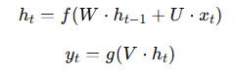
RNN sequential data ko process karta hai by maintaining hidden state:

Where:
- ht​ = hidden state
- xt = input at time t
- W,U,V= weights

🔹 LSTM (Long Short-Term Memory)
LSTM RNN ka advanced version hai jo long-term dependencies handle karta hai.

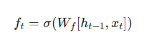
🔸 Gates in LSTM:
- Forget Gate
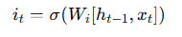
2. Input Gate
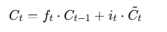
3. Cell State Update
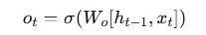
4. Output Gate

LSTM solves:
- Vanishing gradient
- Long-term memory problem

4. Algorithm Limitations

🔹 RNN
- Vanishing gradient problem
- Poor long-term memory

🔹 LSTM
- Slow training
- Computationally expensive
- Requires more data

5. Methodology / Workflow
- Load IMDB dataset
- Preprocess data (padding sequences)
- Build LSTM model
- Train model
- Evaluate performance
- Analyze results

6. Performance Analysis
- Accuracy used for evaluation
- LSTM performs better than simple RNN
- Captures context in sequences

7. Hyperparameter Tuning
- Number of LSTM units
- Epochs
- Batch size
- Sequence length
Code:
# ================= STEP 1: IMPORT =================
import numpy as np
import matplotlib.pyplot as plt
from tensorflow import keras
from tensorflow.keras import layers
from tensorflow.keras.preprocessing.sequence import pad_sequences
# ================= STEP 2: LOAD DATA =================
vocab_size = 10000
(x_train, y_train), (x_test, y_test) = keras.datasets.imdb.load_data(num_words=vocab_size)
# ================= STEP 3: PADDING =================
max_length = 200

x_train = pad_sequences(x_train, maxlen=max_length)
x_test = pad_sequences(x_test, maxlen=max_length)
# ================= STEP 4: BUILD MODEL =================
model = keras.Sequential([
layers.Embedding(vocab_size, 128, input_length=max_length),
layers.LSTM(64),
layers.Dense(1, activation='sigmoid')
])
# ================= STEP 5: COMPILE =================
model.compile(
optimizer='adam',
loss='binary_crossentropy',
metrics=['accuracy']
)
# ================= STEP 6: TRAIN =================
history = model.fit(
x_train, y_train,
epochs=3,
batch_size=64,
validation_split=0.2
)
# ================= STEP 7: EVALUATE =================
loss, acc = model.evaluate(x_test, y_test)
print("Test Accuracy:", acc)

# ================= STEP 8: PLOT =================
plt.plot(history.history['accuracy'], label='train')
plt.plot(history.history['val_accuracy'], label='val')
plt.title("Model Accuracy")
plt.xlabel("Epoch")
plt.ylabel("Accuracy")
plt.legend()
plt.show()
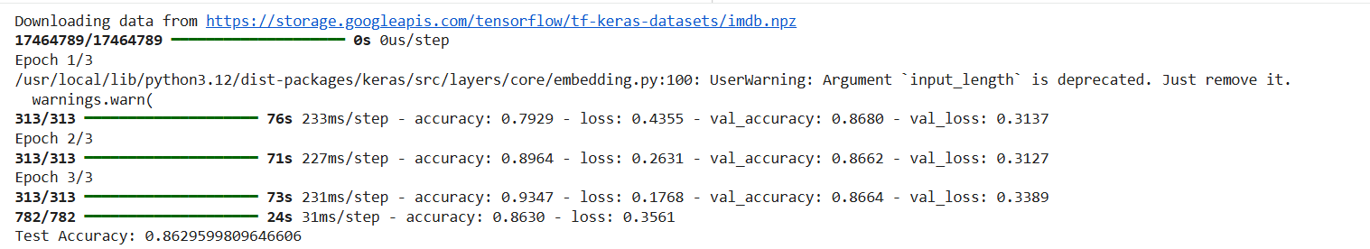
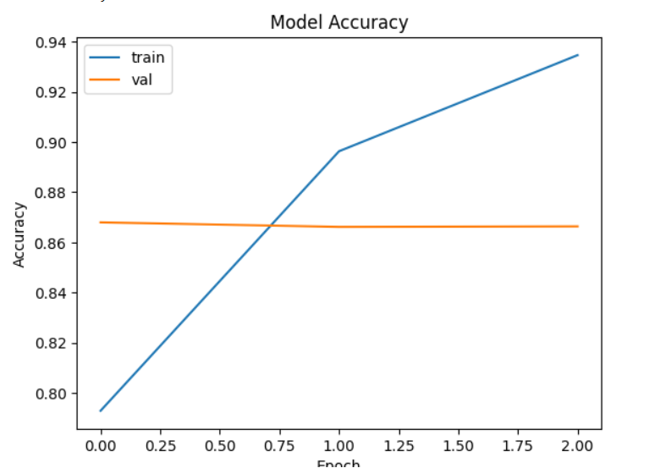
Conclusion:
LSTM was successfully implemented for text classification on the IMDB dataset. The model effectively captured sequential patterns in text and achieved good accuracy, demonstrating the strength of LSTM in handling sequence data.

